**LINUX ASSIGNMENT**

1. ABOSULTE PATH IS : /home/abhijithnair/documents/spreadsheets

2.

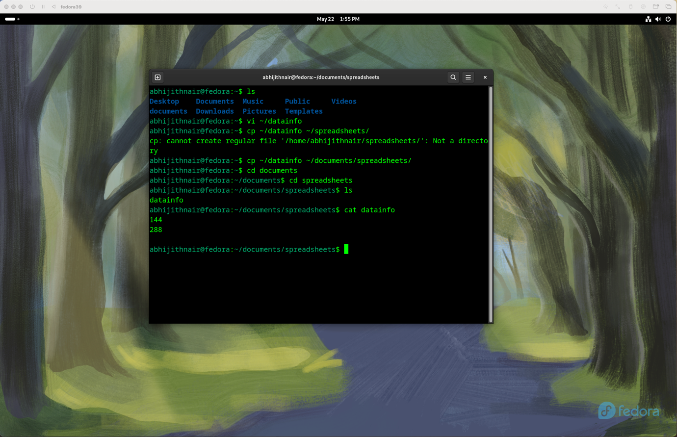

3. 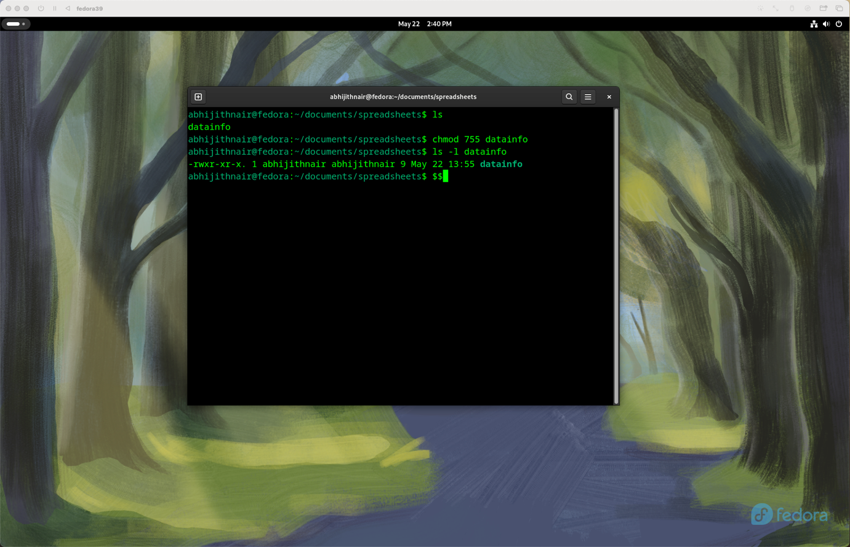

4.

5.

6.

To be discussed in class but class suspended